**GIT Commit Using Command Line- In Master Branch**

**From the Visual studio Team Explorer Select Action and then Open Command Prompt**

1. Check GIT status: **git status**

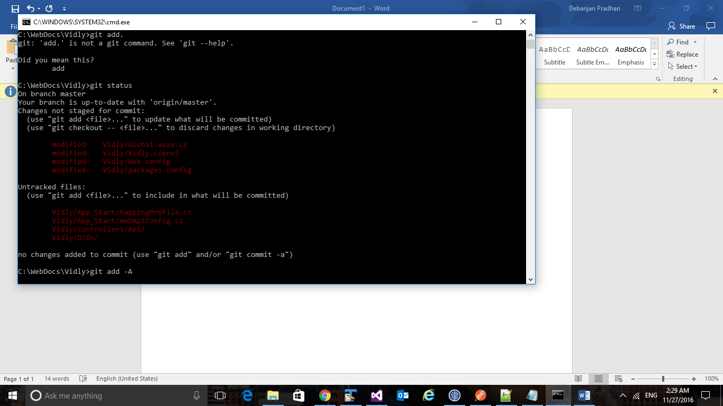

1. Git Add files for commit: **git add -A**

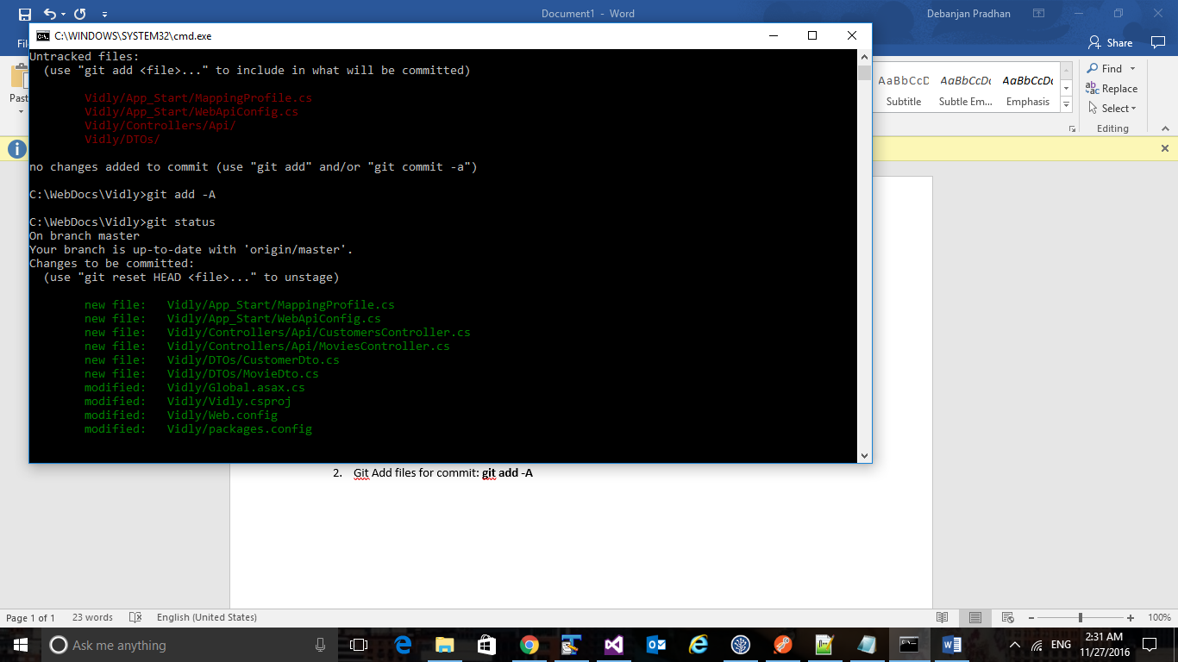

1. Now commit to git : **git commit -m “NOV:Section6 WebAPI”**

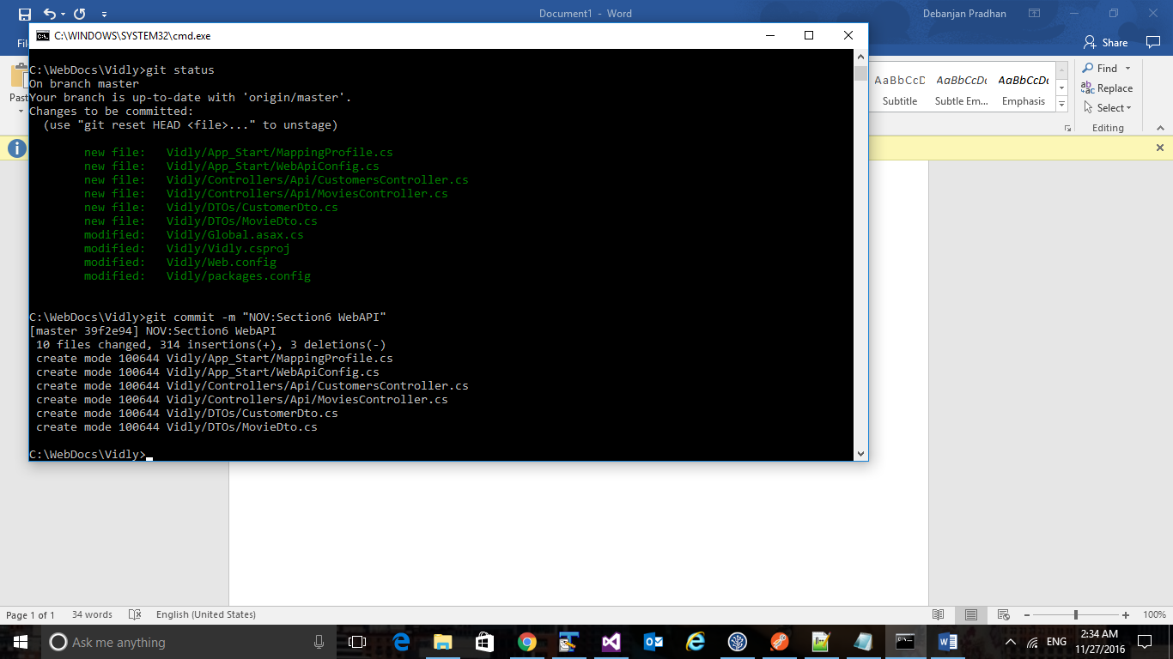

1. You can create another Branch (Other Than Master) in the source Tree , the Branch will appear in the site (<https://github.com/githubDebanjan16/Vidly>) when you Push the branch

Then you can continue working in the branch and once done this can be merged with Master